# Introduction

File Shredder is an OpenSource application that securely removes files and folders from a hard drive and prevents the recovery of those files. There are several applications that can be used to retrieve and/or recover deleted files from a Windows Operating System. Those applications are often referred to as "file recovery" software and take advantage of limitation in the Windows "delete" command that is used to delete files. The "delete" operation in Windows only removes bits of information from files so that they appear deleted, however it is easy to retrieve those files using specialised file recovery software.

To remove or shred files permanently from a system, a program that rewrites those files with random series of binary data multiple times, must be used. This process is often called file shredding. This results in the actual content of the file being overwritten and the possibilities to recover such a shredded file are mostly theoretical.

# Preparation (on separate machine)

1. Download File Shredder from the following location:

<https://www.fileshredder.org/files/file_shredder_setup.exe>

1. Locate and double click the setup file “file_shredder_setup.exe” and follow the default installation options.
2. Once the installation has completed, select “Launch File Shredder” and click “Finish”.

# Selecting file and folders for secure removal/shredding

1. 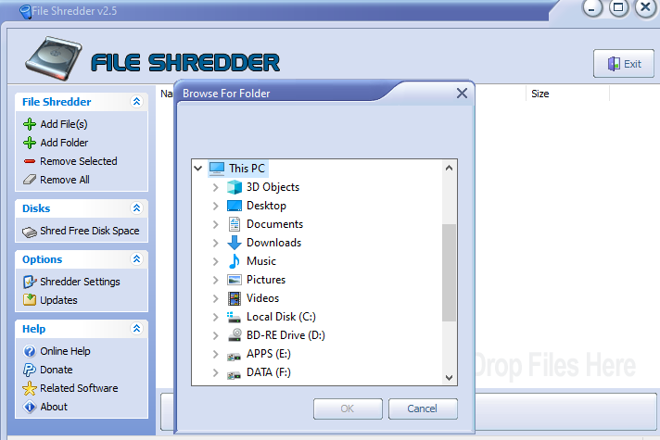Once File Shredder has opened click on “Add Folder”, under the File Shredder menu and navigate to the folder containing the information that needs to be securely removed.
2. Multiple folders can be added using the “Add Folder” menu option or simply “Drag & Drop” the files and folders into the application window. Once all the desired files and folders have been added, click on “Shred Files Now”.

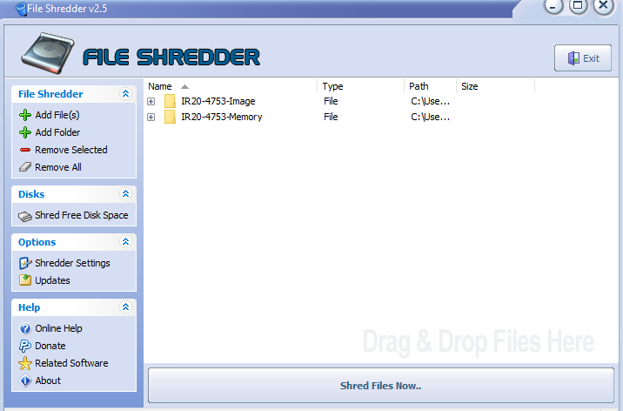

1. A ***final*** confirmation prompt will appear and if the operator is certain of this action, click on “OK” after which the shredding process will commence.

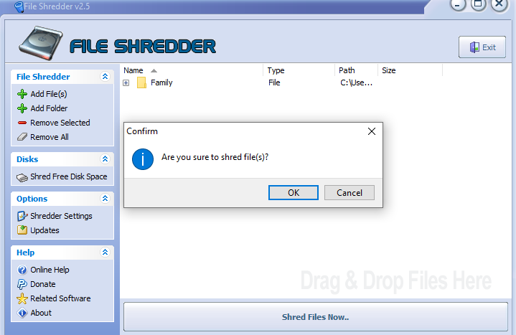

1. The shredding process will complete automatically and do not require additional actions. Once the shredding process has completed the File Shredder application may be closed.
2. Navigate to the original location where the shredded folders resided and confirm that they have been securely removed.